We are all graduate students of CMU, so I reckon that the information about CMU graduates and their career prospects should be appealing to us.

First of all, let’s look into some basic information about those CMU graduates.

**All of the sketches will be replaced.**

* **Introduction to CMU Graduates**
* **Common Industry by Major**

The most common industries for people who hold a degree in one of the 5 most specialized majors at Carnegie Mellon University are [Computer Systems Design](https://datausa.io/profile/naics/5415) (937,805 people), [Architectural, engineering & related services](https://datausa.io/profile/naics/5413) (579,812 people), [Colleges, universities & professional schools, including junior colleges](https://datausa.io/profile/naics/611M1) (430,631 people), [Construction](https://datausa.io/profile/naics/23) (318,639 people), and [Elementary & secondary schools](https://datausa.io/profile/naics/6111) (263,952 people).

The most specialized majors at Carnegie Mellon University are [Engineering](https://datausa.io/profile/cip/14) (1,451 degrees awarded), [Computer and Information Sciences and Support Services](https://datausa.io/profile/cip/11) (1,216 degrees), [Math & Statistics](https://datausa.io/profile/cip/27) (213 degrees), [Physical Sciences](https://datausa.io/profile/cip/40) (204 degrees), and [Architecture and Related Services](https://datausa.io/profile/cip/04) (64 degrees).

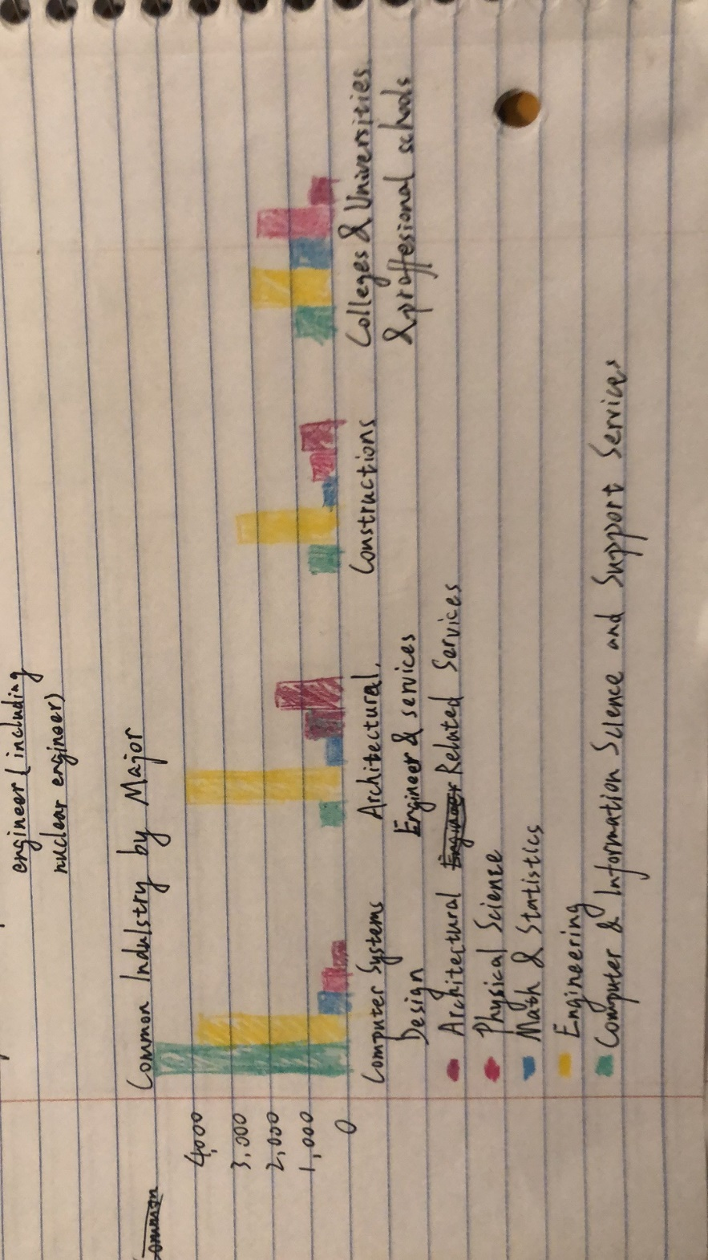

* **Majors Awarded**

Most Common

1. [Computer Science](https://datausa.io/profile/cip/110701)

184 degrees awarded

1. [Electrical & Electronics Engineering](https://datausa.io/profile/cip/141001)

163 degrees awarded

1. [Mechanical Engineering](https://datausa.io/profile/cip/141901)

107 degrees awarded

In 2017, the most common bachelors degree concentration at Carnegie Mellon University was [Computer Science](https://datausa.io/profile/cip/110701) with 184 degrees awarded.

This visualization illustrates the percentage of degree recipients from bachelors degree programs at Carnegie Mellon University according to their major.

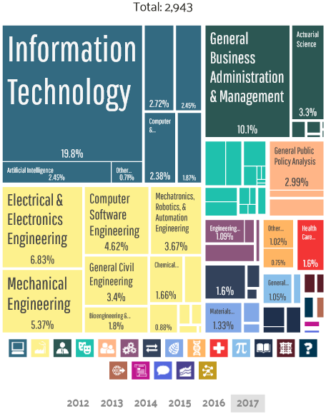

As we can see from our data above, there are lots of students in CMU major in computer science and information technology. Because of this major situation, most common industry for CMU students are in computer system design, architectural engineer & related services.

* **Heinz Student Occupation**

Most of the students in this course Telling Stories with Data are Heinz students, so let’s look into some data about our Heinz students. The master degree that Heinz offer include: MISM, MSPPM, MSISPM, etc. They all fall into the category of Computer and Information Sciences and Support Services. Let’s just see what’s the occupation of those graduates students.

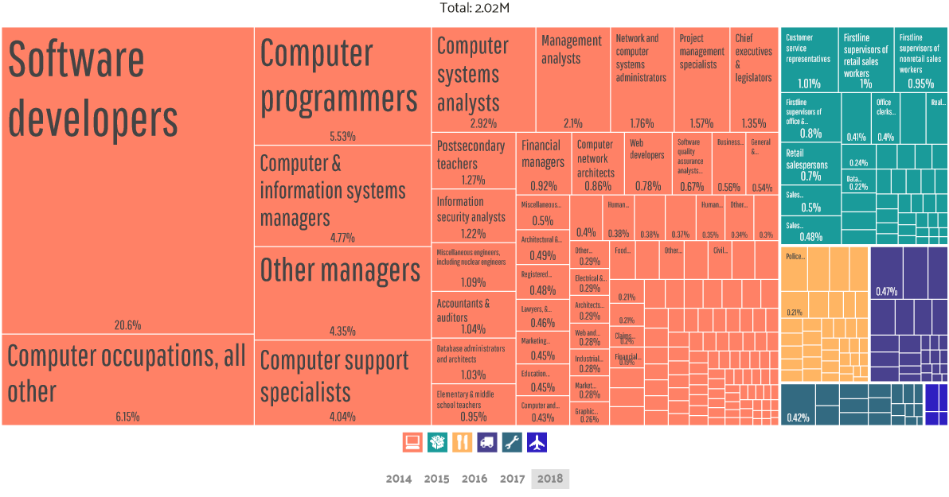

It’s quite clear that over 50% of our Heinz students working in management, business, science & arts. Actually, this picture just support our long-time impression about our career prospects. It matches with industries of those companies which come to Heinz to hire students.

So, the most important question comes. How’s our alumnus doing in their work? How’s their income? And among those broad occupations like management, business, science & arts, which detailed industries offer better salary? Which cities offer more? Which occupation has better gender balance?

* **Career Prospects**
* **Salary**

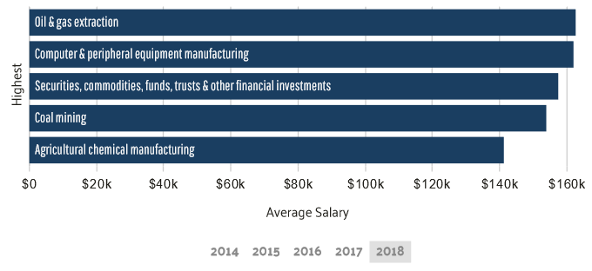

For the average salary, this bar chart above shows the top 5 specific industries of management, business, science & arts in 2018, the United States.

Now, we have an understanding about the most generous industries for us information science students. So if we want to get paid well, we should aim to work in companies like Mobil, IBM, FireEye, Salesforce, etc.

* **Location**

Other than that, the working location also matters.

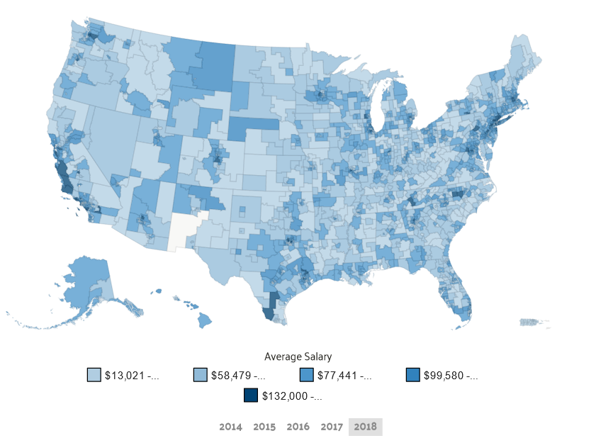

(Other than a large map shows the average salary location, I plan to add a bar chart to show the top 10 area which offer the highest average salary for information industries occupations.)

HIGHEST PAYING PUMAS

1. [Humboldt County PUMA, CA](https://datausa.io/profile/geo/79500US0602300)
2. [Mountain View, Palo Alto & Los Altos Cities PUMA, CA](https://datausa.io/profile/geo/79500US0608501)
3. [Montgomery County (South)The Woodlands (North) PUMA, TX](https://datausa.io/profile/geo/79500US4804503)

This map shows which public use microdata areas (PUMAs) pay the highest average salary to employees in the Information Industry Sub-Sector.

In a bigger picture, California, Texas, New York, Seattle pay well.

* **Age (PLAN to add more explain in the age part, this part can demonstrate whether information industry is suitable for long time development. Can Compare this with the age distribution in technology industry)**

For the age distribution:

Average Male Age in 2018 is 41.9 years old.

Average Female Age in 2018 in 40.6 years old.

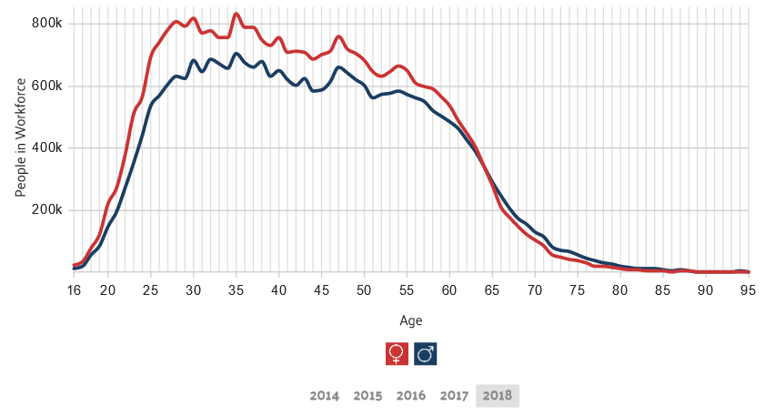

This chart shows distribution of ages for employees with a degree in [Computer and Information Sciences and Support Services](https://datausa.io/profile/cip/11). The most common ages of employees with this major are 37 and 36 years old, which represent 3.75% and 3.74% of the population, respectively. Male employees are generally 1.29 years older than their Female counterparts.

* **Gender**

For the gender compostion, 53.4% of Management, business, science, & arts occupations are Female, making them the more common gender in the occupation. So I believe for most of the jobs, we do not worry about gender unbalance, and this can show that in a way, in management, business, science, & arts, the sexism might not be a harsh problem.

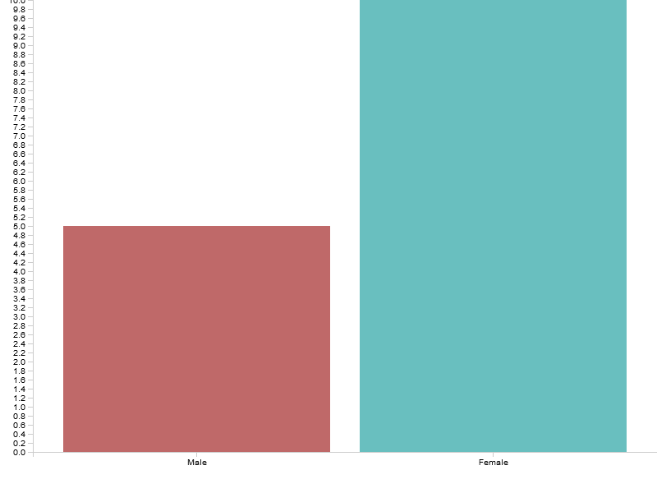

(A gender distribution chart for detailed occupations will replace the current one.)

* **Working hours**

I will find some data about the working hours per week for some popular information industry occupations mentioned above to demonstrate if this job is too tiring.

* **Conclusion**

The highest paying industries of [Computer and Information Sciences and Support Services](https://datausa.io/profile/cip/11) majors, by average wage, are [Internet publishing, broadcasting & web search portals](https://datausa.io/profile/naics/51913), [Other consumer goods rental](https://datausa.io/profile/naics/532M2), and [Sound recording industries](https://datausa.io/profile/naics/5122). The highest paying industries of [Business](https://datausa.io/profile/cip/52) majors, by average wage, are [Oil & gas extraction](https://datausa.io/profile/naics/211), [Computer & peripheral equipment manufacturing](https://datausa.io/profile/naics/3341), and [Securities, commodities, funds, trusts & other financial investments](https://datausa.io/profile/naics/52M2).

California, Texas, New York, Seattle pay well.

For any students who are less than 42, we should have a great development space in our career.

We shouldn’t worry too much about the gender imbalance.

(A better conclusion with some chart will be added)